Exp. No: 1
Date:
Transformation between Cartesian, Cylindrical and spherical coordinate system
Aim:
To write program for Transformation between Cartesian, Cylindrical and spherical coordinate system using SCILAB.
Software required:
•SCILAB version 6.0.1
Program:
Test case (i) Transformation of Cartesian coordinate points in to Cylindrical and spherical coordinate system
clc;
x=input('Enter the value of X=');
y=input('Enter the value of y=');
z=input('Enter the value of z=');
r=sqrt(x^2+y^2);
pi=atand(y/x);
disp('Cartesian to cylindrical coordinate system of p(r,pi,z)=',[r pi z]);
r=sqrt(x^2+y^2+z^2);
theta=acosd(z/r);
pi=atand(y/x);
disp('Cartesian to spherical coordinate system of s(r,theta,pi)=',[r theta pi]);
Output:-
Enter the value of X=-3
Enter the value of y=5
Enter the value of z=-11
"cartesain to cylinderical coordinate system of p(r,pi,z)="
5.8309519 -59.036243 -11.
"cartesain to spherical coordinate system of s(r,theta,pi)="
12.4499 152.07254 -59.036243
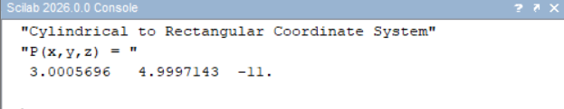
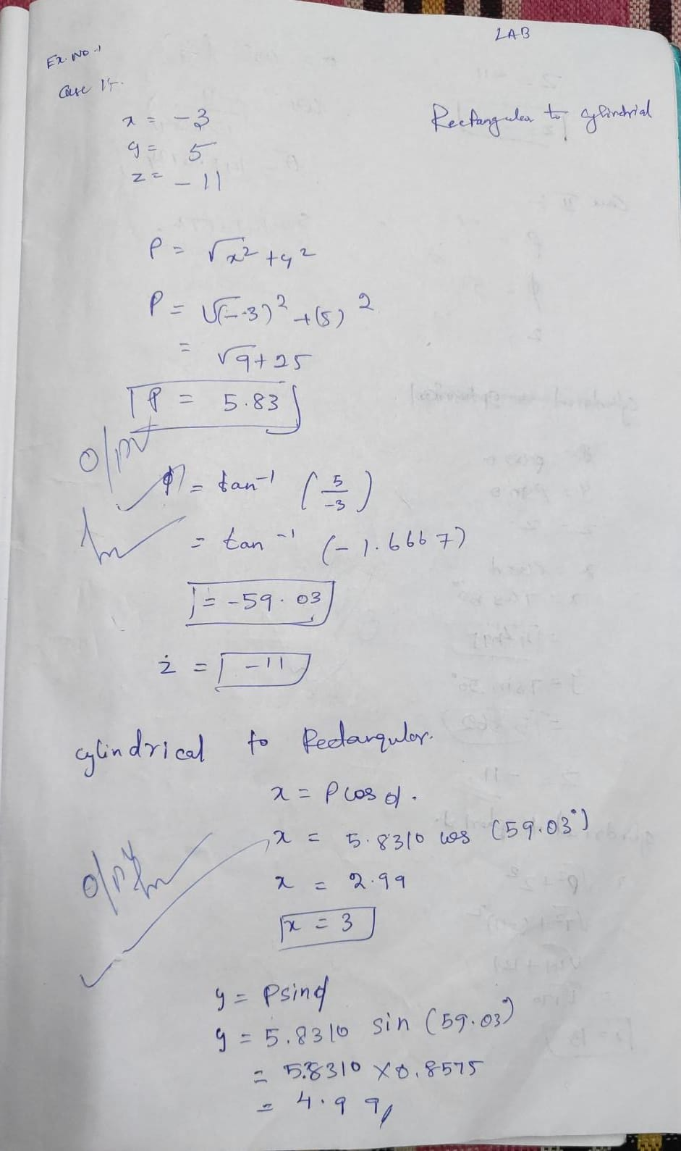

Test case (ii) Transformation of Cylindrical coordinate points into Cartesian and spherical coordinate system

Clc;
r=input('Enter the value of r=');
pi=input('Enter the value of pi=');
z=input('Enter the value of z=');
x=r*cosd(pi);
y=r*sind(pi);
z=z;
disp('cylindrical to cartesian coordinate system of p(x,y,z)=',[x y z]);
r=sqrt(r^2+z^2);
pi=pi;
theta=acosd(z/r);
disp('cylindrical to spherical coordinate system of s(r,pi,theta)=',[r pi theta]);
Output:-
Enter the value of r=7
Enter the value of pi=50
Enter the value of z=-11
"cylinderical to cartesian coordinate system of p(x,y,z)="
4.4995 5.36231 -11.8014.
"cylinderical to spherical coordinate system of s(r,pi,theta)="
13.0384 50.0000 147.572
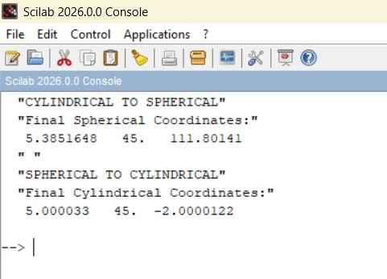

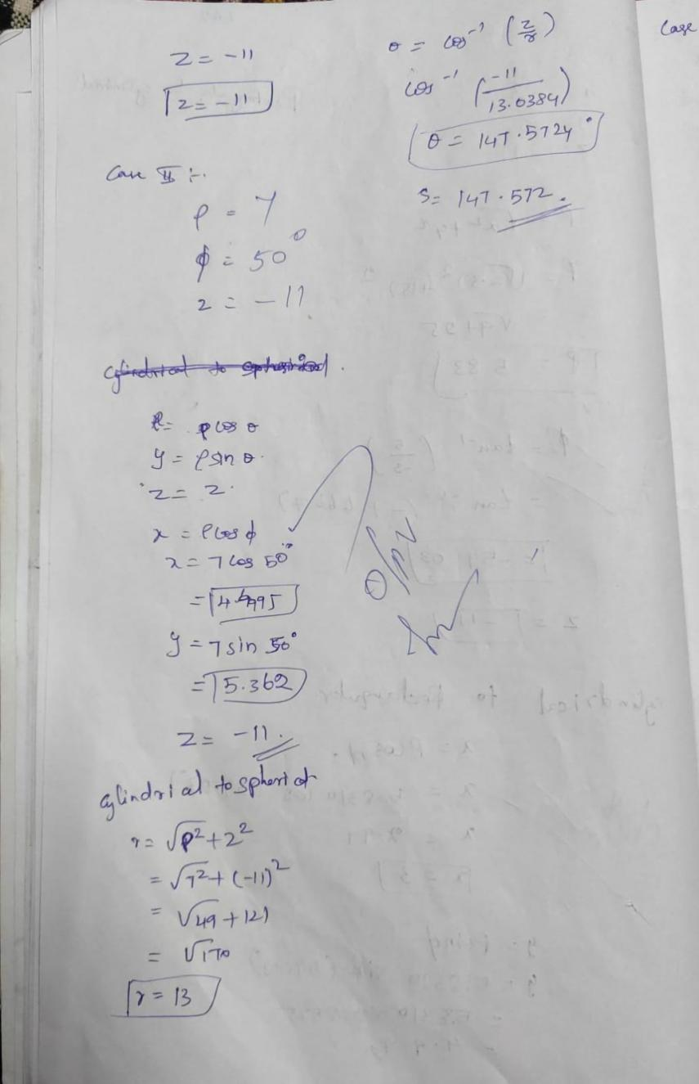

Test case (iii) Transformation of spherical coordinate points into Cylindrical and Cartesian coordinate system
clc;
r=input('Enter the value of r=');
pi=input('Enter the value of pi=');
theta=input('Enter the value of theta=');
x=r*sind(theta)*cos(pi);
y=r*sind(theta)*sin(pi);
z=r*cosd(theta);
disp('spherical to cartesian coordinate system of p(x,y,z)=',[x y z]);
p=r*sin(theta);
pi=pi;
z=r*cos(pi);
disp('spherical to cylindrical coordinate system of s(p,pi,z)=',[p pi z]);

Output:-
Enter the value of r=5
Enter the value of pi=30
Enter the value of theta=60

"spherical to cartesian coordinate system of p(x,y,z)="
1.25 2.1650635 4.330127

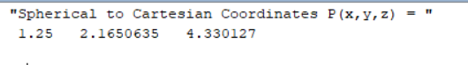
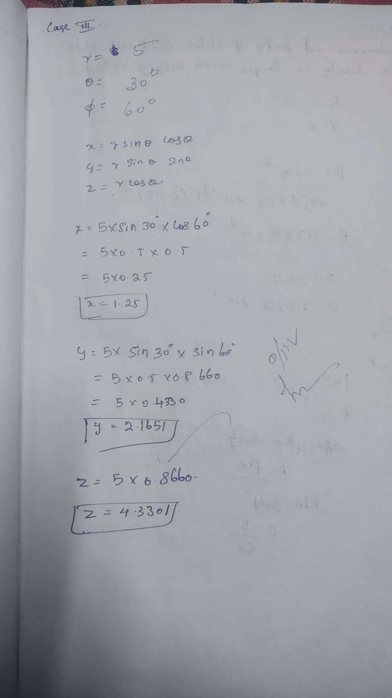
Result:
Thus, the program was verified Transformation between Cartesian and Cylindrical coordinate system its classified two categories (a) Cartesian to cylindrical and spherical coordinate system (b) Cylindrical to cartesian and spherical coordinate system (c) spherical to cartesian and cylindrical coordinate system using SCILAB was successfully.

